**JS Applications Regular Exam – MindNest**

**Environment Specifics**

Please be aware that every JS environment may **behave differently** when executing code. Certain things that work in the browser are not supported in **Node.js**, which is the environment used by **Judge**.

The following actions are **NOT** supported:

* **.forEach()** with **NodeList** (returned by **querySelector()** and **querySelectorAll()**)
* **.forEach()** with **HTMLCollection** (returned by **getElementsByClassName()** and **element.children**)
* Using the **spread-operator** (**...**) to convert a **NodeList** into an array
* **append()** in Judge (use only **appendChild()**)
* **prepend()**
* **replaceWith()**
* **replaceAll()**
* **closest()**
* **replaceChildren()**
* Always turn the collection into a **JS array** (forEach, forOf, et.)

If you want to perform these operations, you may use **Array.from()** to first convert the collection into an array.

In this exam, you are expected to exclusively utilize JavaScript without relying on external frameworks like React, Vue, or Angular to tackle the given challenges.

You are assigned to implement a **Web application** (SPA) using JavaScript. The application should dynamically display content, based on user interaction and support user-profiles and CRUD operations, using a REST service.

1. **Overview**

**Implement** a front-end app (**SPA**) for creating and managing **mindful tips records**. The application allows visitors to browse through the **Mindful Tips** catalog. Users may **register** with an **email** and a **password** which allows them to **create** their own tips records info. Item authors can also **edit** or **delete** their own publications at any time.

1. **Technical Details**

You are provided with the following resources:

* **Project scaffold**: A **package.json** file, containing a list of common dependencies. You may change the included libraries to your preference. The sections **devDependencies** and **scripts** of the file are used by the automated testing suite, altering them may result in an incorrect test operation.

To **initialize** the project, execute the command **npm install** via the command-line terminal.

* **HTML** **and CSS files**: All views (pages) of the application, including **sample** user-generated **content**, are included in the file **index.html**, which links to CSS and other static files. **Each view is in a separate section** of the file, which can be identified by a **unique class name or id** attribute. Your application may use any preferred method (such as a **templating library** or manual visibility settings) to display only the selected view and to **navigate** between views upon user interaction.
* **Local** **REST service**: A special server, which contains **sample data** and supports **user registration** and **CRUD operations** via REST requests is included in the project. Each section of this document (where applicable) includes details about the necessary **REST endpoints**, to which **requests** must be sent, and the **shape** of the expected **request body**.

For **more information** on how to use the included server, see **Appendix A: Using the Local REST Service** at the end of this document.

* **Automated tests**: A complete test suite is included, which can be used to test the correctness of your solution. **Your work will be assessed, based on these tests.**

For **more information** on how to run the tests, see **Appendix B: Running the Test Suite** at the end of this document.

**Do not use CDN** for loading the dependencies because it can **affect the tests in a negative** **way**!

**Note:** When creating HTML elements and displaying them on the page, **adhere as close as possible to the provided HTML** samples. Changing the structure of the document may **prevent the tests** from running correctly, which will **adversely affect your assessment grade**. You may **add attributes** (such as **class** and **dataset**) to any HTML Element, as well as **change the "href"** attributes on links and add/change the **method** and **action** attributes of HTML Forms, to facilitate the correct operation of a routing library or another method of abstraction. You may also add hidden elements to help you implement certain parts of the application requirements.

1. **Application Requirements**

**Navigation Bar (5 pts)**

Implement a **NavBar** for the app:

Navigation links should correctly change the current page (view). All users can see the site **logo** that should be a link to the **Home** page as well as the navigation link to **Mindful Tips** page. **Guests** (un-authenticated visitors) can see the links to the **Login** and **Register**. The logged-in user navbar should contain the links to the **Share Your Tip**, page and a link for the **Logout** action.

**Logged-in User** navigation example:



**Guest** navigation example:



**Home Page (10 pts)**

Implement a static **Home page** for the app using the structure for it from the given resources. 

**Login Page (5 pts)**

The **included REST service** comes with the following **premade** user accounts, which you may use for development:

**{ "email": "peter@abv.bg", "password": "123456" }**

**{ "email": "john@abv.bg", "password": "123456" }**

The **Login** page contains a form for existing user authentication. By providing an **email and password** the app should log a user in the system **if** there are **no empty fields**.

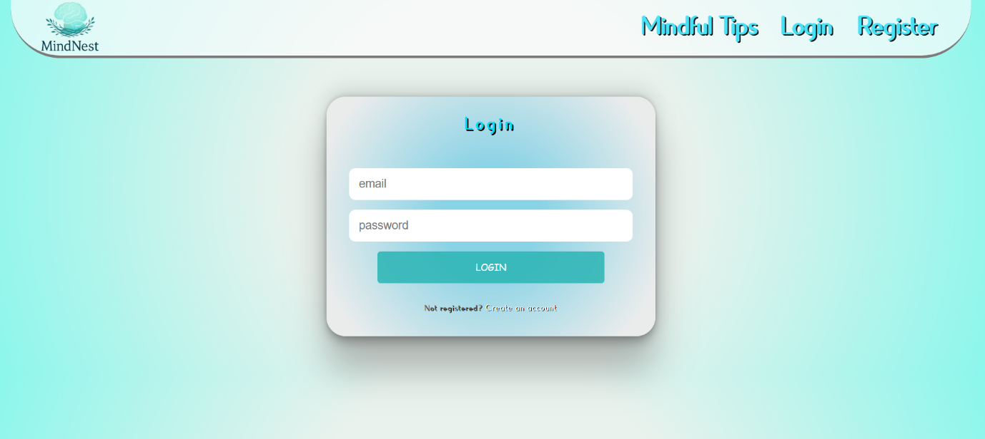

Send the following **request** to perform login:

**Method:** POST

**URL:** /users/login

The required **headers** are described in the documentation. The service expects a body with the following shape:

**{**

**email,**

**password**

**}**

Upon success, the **REST service** will return the newly created object with an automatically generated **_id** and a property **accessToken**, which contains the **session token** for the user **–** you need to store this information using **sessionStorage** or **localStorage,** in order to be able to perform authenticated requests.

If the login was successful, **redirect** the user to the **Home** page. If there is an error, or the **validations** don’t pass, display an appropriate error message, using a system dialog (**window.alert**).

**Register Page (10 pts)**

When the user enters an **email,** a **password** and a **password confirmation**, theapp should register a new user in the system. All fields are required – if any of them is empty, or the **password** and **repeat password** doesn't match, display an **error** with text "**Passwords don't match**".

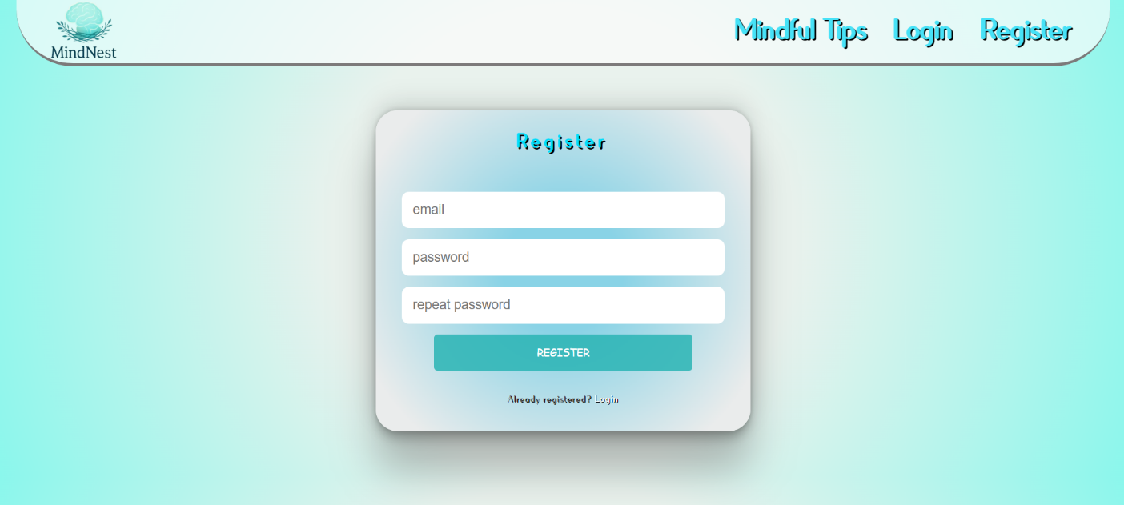

Send the following **request** to perform registration:

**Method:** POST

**URL:** /users/register

Required **headers** are described in the documentation. The service expects a body with the following shape:

**{**

**email,**

**password**

**}**

Upon success, the **REST service** will return the newly created object with an automatically generated **_id** and a property **accessToken**, which contains the **session token** for the user **–** you need to store this information using **sessionStorage** or **localStorage,** in order to be able to perform authenticated requests.

If the registration was successful, **redirect** the user to the **Home** page. If there is an error, or the **validations** don’t pass, display an appropriate error message, using a system dialog (**window.alert**).

**Logout (5 pts)**

The logout action is available to **logged-in users**. Send the following **request** to perform logout:

**Method:** GET

**URL:** /users/logout

The required **headers** are described in the documentation. Upon success, the **REST service** will return an **empty response**. Clear any session information you’ve stored in browser storage.

If the logout was successful, **redirect** the user to the **Home** page.

**Dashboard (15 pts)**

This page displays a list of all Tips in the system. Clicking on the **View Tip** button in the item leads to the details page for the selected item. This page should be visible to guests and logged-in users.

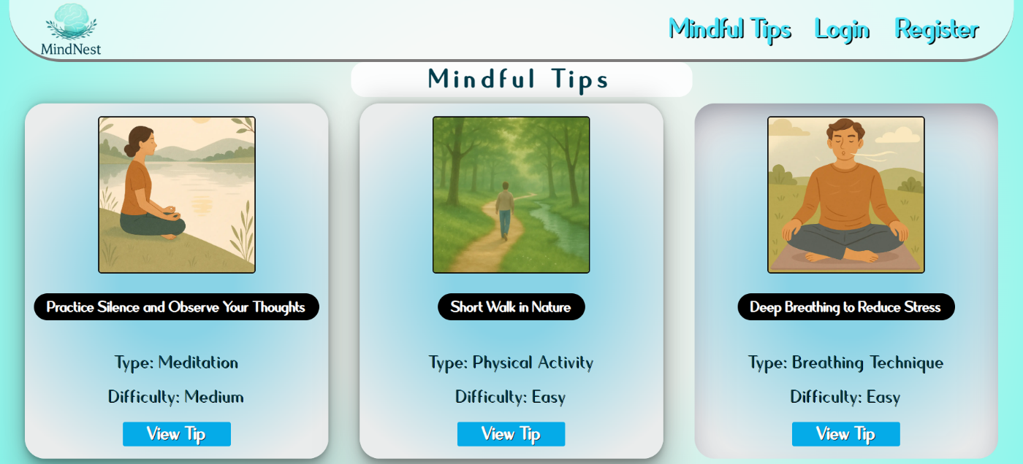

If there are **no Tips**, the following view should be displayed:

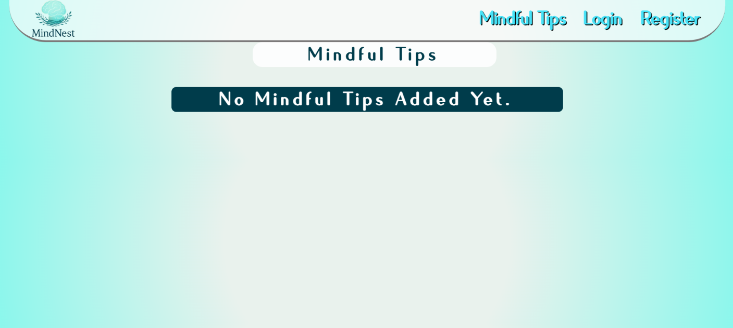

Send the following **request** to read the list of records:

**Method:** GET

**URL:** /data/mindfultips?sortBy=_createdOn%20desc

The required **headers** are described in the documentation. The service will return an array of Items.

**Adding a New Tip(15 pts)**

The Create page is available to **logged-in users**. It contains a form for adding a new tip. Check if all the fields are filled before you send the request.

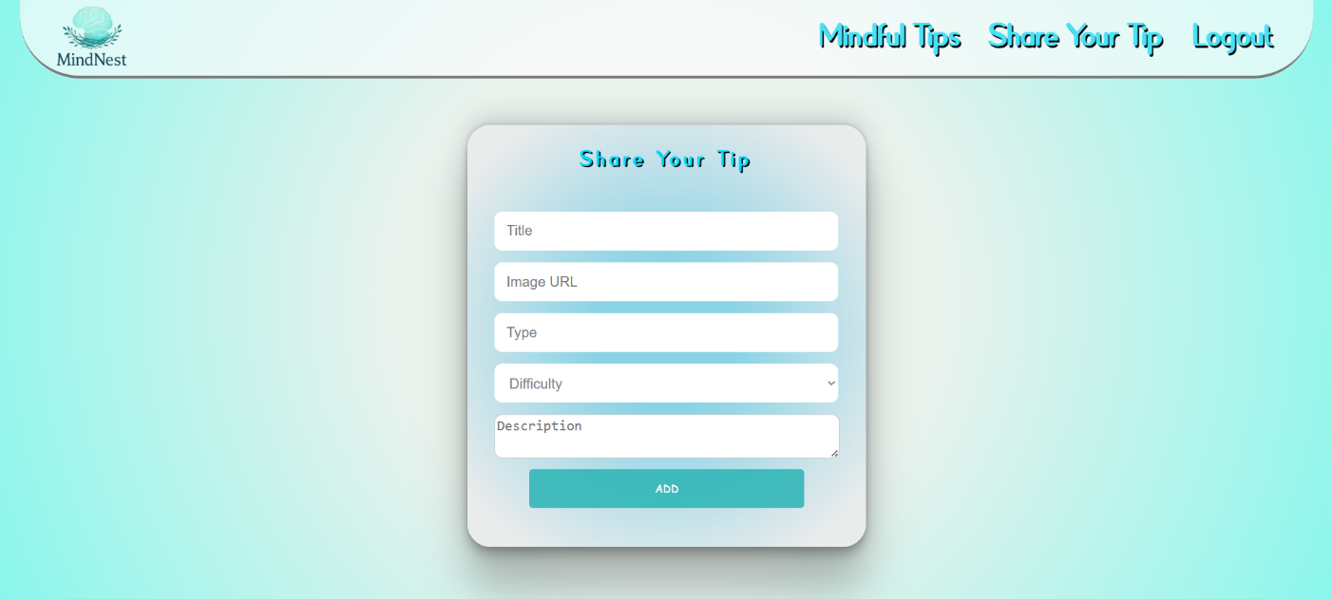

To create Tip record, send the following **request**:

**Method:** POST

**URL:** /data/mindfultips

The required **headers** are described in the documentation. The service expects a body with the following shape:

**{**

**title,**

**imageUrl,**

**type,**

**difficulty,**

**description**

**}**

The required **headers** are described in the documentation. The service will return the newly created record. Upon success, **redirect** the user to the **Mindful Tips** page.

**Tip Details (10 pts)**

All users should be able to **view details** aboutTip. Clicking the **View Tip** button in a **item** should **display** the **Details** page. If the currently **logged-in user** is the **creator**, the **Edit** and **Delete** buttonsshould be displayed. Otherwise, they should not be available. The view should look like this to the **creator** of the record:

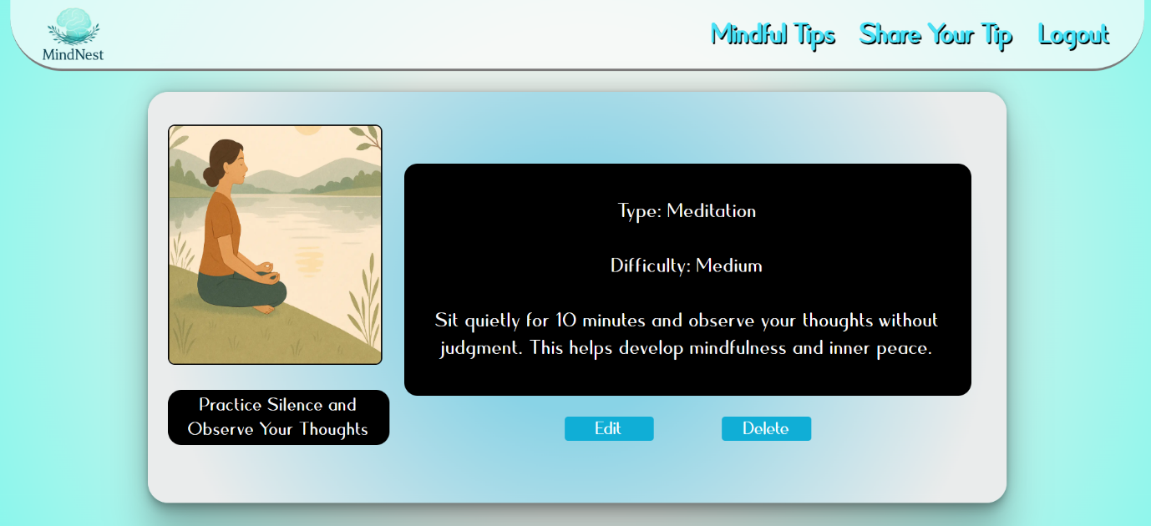

The view for **guests** and **registered** users who have not created the record should look like:

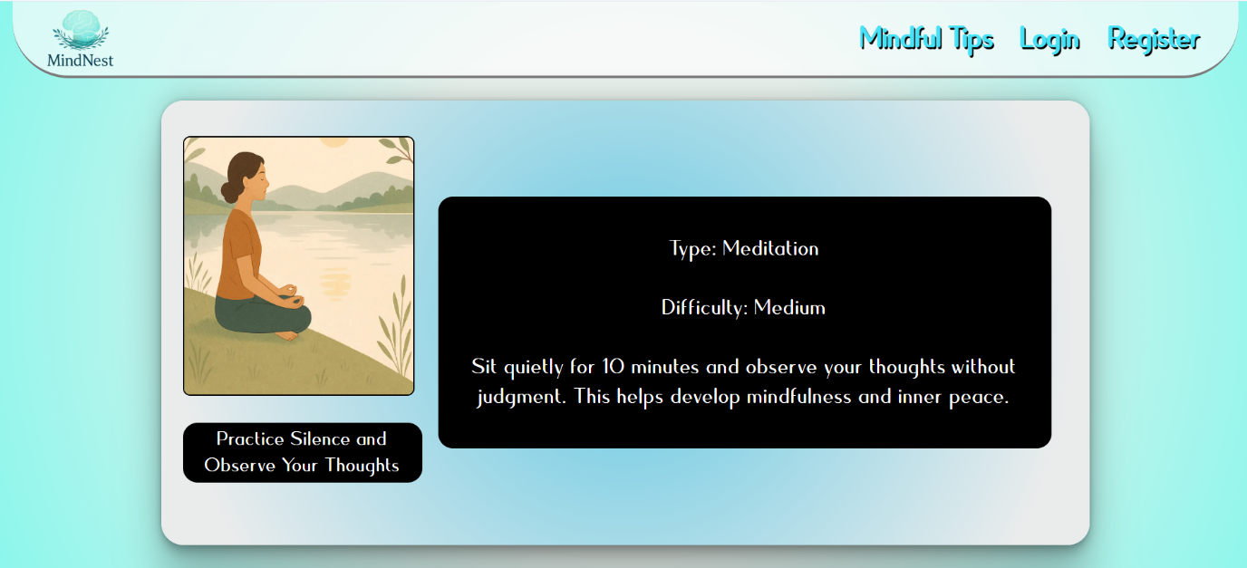

Send the following **request** to read a single item:

**Method:** GET

**URL:** /data/mindfultips/***:id***

Where ***:id*** is the **ID** of the desired item. The required **headers** are described in the documentation. The service will return a single object.

**Editing a Record (15 pts)**

The Edit page is available to logged-in users and it allows authors to **edit** their **own** records. Clicking the **Edit** link of a particular item on the **Details** page should display the **Edit** page, with all fields filled with the data for the item. It contains a form with input fields for all relevant properties. Check if all the fields are filled before you send the request.

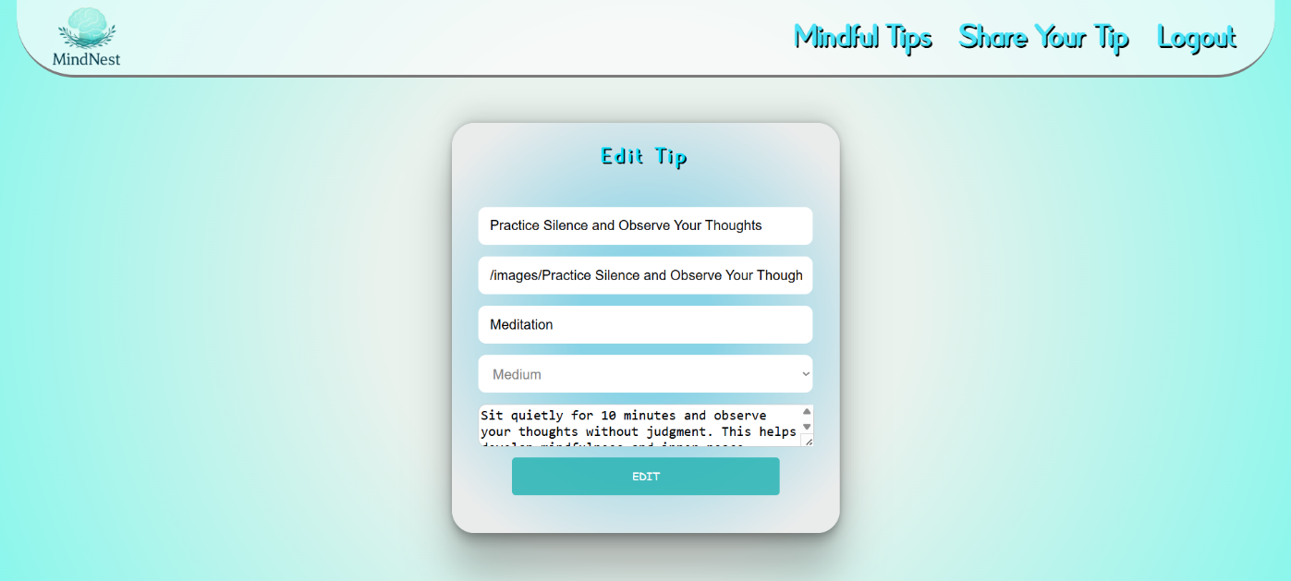

To edit a tip record, send the following **request**:

**Method:** PUT

**URL:** /data/mindfultips/***:id***

Where ***:id*** is the **id** of the desired tip.

The service expects a **body** with the following shape:

**{**

**title,**

**imageUrl,**

**type,**

**difficulty,**

**description**

**}**

Required **headers** are described in the documentation. The service will return the modified record. Note that **PUT** requests **do not** merge properties and will instead **replace** the entire record. Upon success, **redirect** the user to the **Details** page for the current item.

**Delete a Record (10 pts)**

The delete action is available to **logged-in users**, for item records they have created. When the author clicks on the Delete action on any of their item, **a confirmation dialog should be displayed**, and upon confirming this dialog, the record should be **deleted** from the system.

To delete item record, send the following **request**:

**Method:** DELETE

**URL:** /data/mindfultips/***:id***

where ***:id*** is the **id** of the desired item. Required **headers** are described in the documentation. The service will return an object, containing the deletion time. Upon success, **redirect** the user to the **Mindful Tips** page.

### BONUS: Notifications (15 pts)

In case of **error caused by the user’s actions**, the application should display an **error notification message instead of an alert**, which disappears after 3 seconds. There is a **styled section** with **id "notifications"** and **styled div** with **id="errorBox" that has** CSS property **display** initially set to **none** in the provided HTML file.

Errors may include **validation errors** or error **messages returned** by the REST service, such as incorrect user credentials, on the following pages: **Register**, **Login**, **Create** and **Edit**.

Some of the tests are made to catch both window.alert and error notification message, you should **only use one** way to **display errors**!

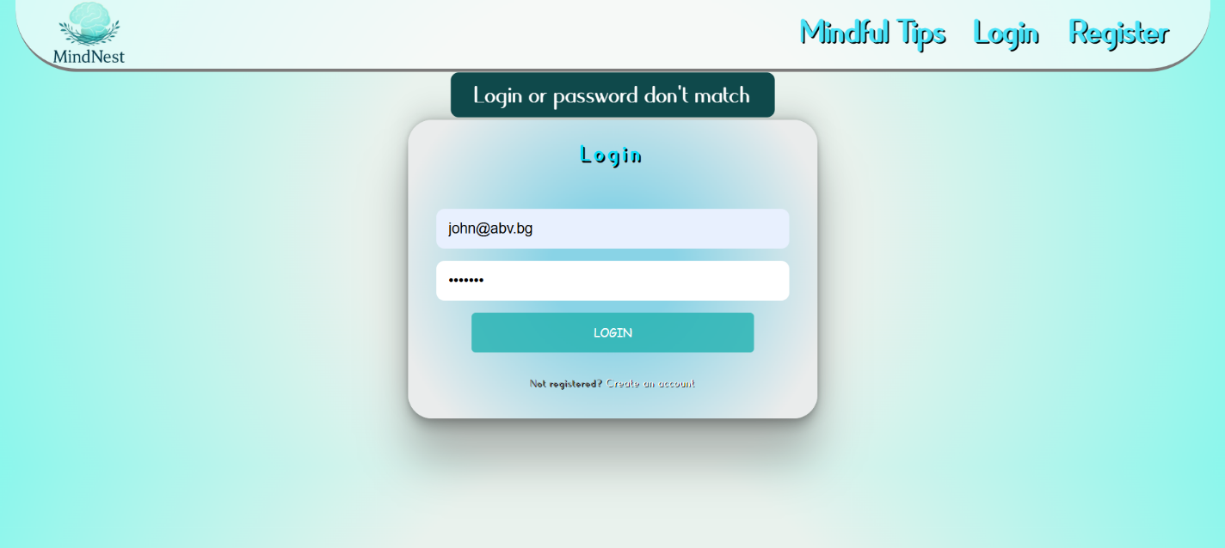

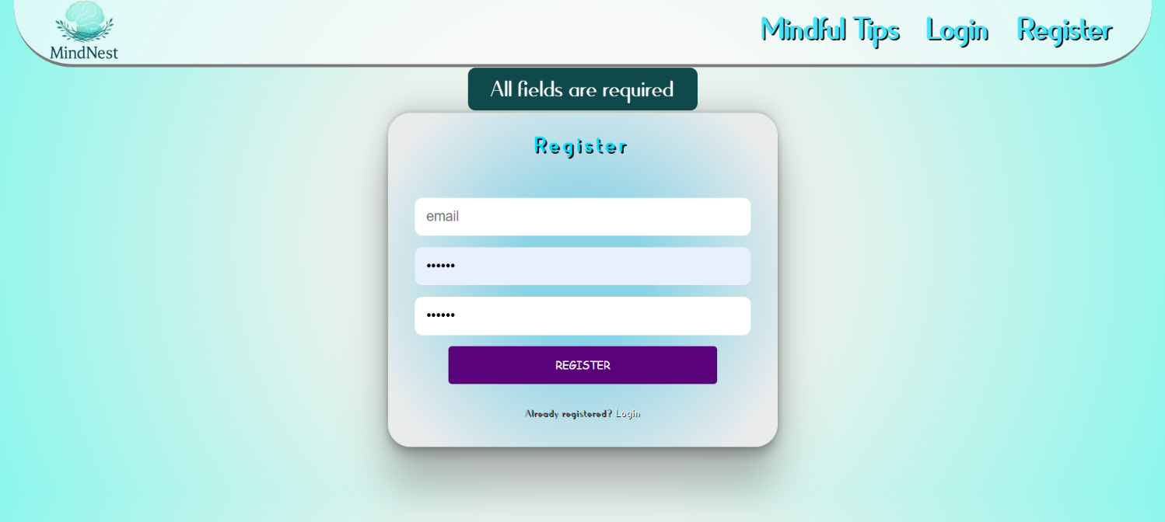

1. **Submitting Your Solution**

Place in a **ZIP** file your project folder. Exclude the **node_modules** folder. Upload the archive to Judge.

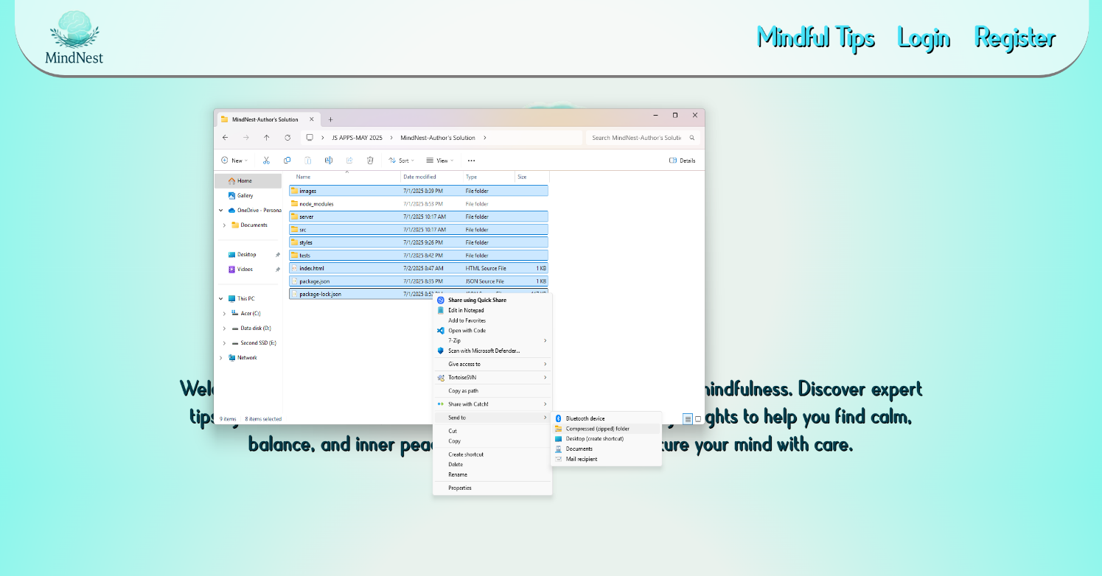

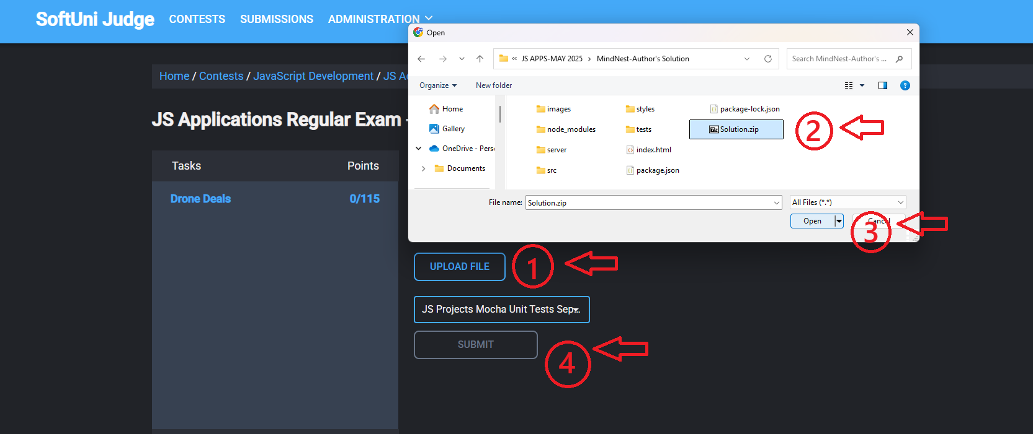

**It will take several minutes for Judge to process your solution!**

1. **Appendix A: Using the Local REST Service**

**Starting the Service**

The REST service will be in a folder named “server” inside the provided resources archive. It has no dependencies and can be started by opening a terminal in its directory and executing:

**node server.js**

If everything is initialized correctly, you should see a message about the **host address and port** on which the service will respond to requests.

**Sending Requests**

To send a request, use the **hostname** and **port**, shown in the initialization log and **resource address** and **method** as described in the **application requirements**. If data needs to be included in the request, it must be **JSON-encoded**, and the appropriate **Content-Type** **header** must be added. Similarly, if the service is to return data, it will be JSON-encoded. Note that **some requests do not return a body** and attempting to parse them will throw an exception.

Read requests, as well as login and register requests do not require authentication. All other requests must be authenticated.

**Required Headers**

To send data to the server, include a **Content-Type** header and encode the body as a JSON-string:

**Content-Type: application/json**

*{JSON-encoded request body as described in the application requirements}*

To perform an authenticated request, include an **X-Authorization** header, set to the value of the **session token**, returned by an earlier login or register request:

**X-Authorization:** *{session token}*

**Server Response**

Data response:

**HTTP/1.1 200 OK**

**Access-Contrоl-Allow-Origin: \***

**Content-Type: application/json**

*{JSON-encoded response data}*

Empty response:

**HTTP/1.1 204 No Content**

**Access-Contrоl-Allow-Origin: \***

Error response:

**HTTP/1.1 400 Request Error**

**Access-Contrоl-Allow-Origin: \***

**Content-Type: application/json**

*{JSON-encoded error message}*

**More Information**

You can find more details on the [GitHub repository of the service](https://github.com/softuni-practice-server/softuni-practice-server/blob/master/README.md).

1. **Appendix B: Running the Test Suite**

**Project Setup**

The tests require a web server to deliver the content of the application. There is a development web server included in the project scaffold, but you may use whatever server you are familiar with. Note that specialized tools like **BrowserSync** may interfere with the tests. To initialize the project with its dependencies, open a terminal in the folder, containing the file **package.json** and execute the following:

**npm install**

Note that if you changed the section **devDependencies** of the project, the tests may not initialize properly.

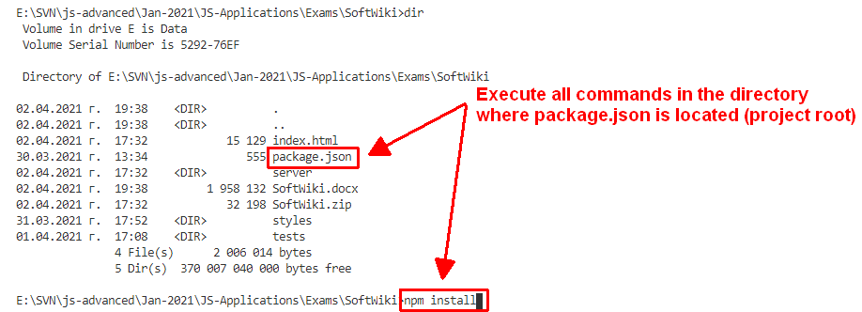

**Executing the Tests**

Before running the test suite, **ensure** that the **web server is operational**, **that the local REST Service is stopped,** and that the application can be found at the root of its network address. To start the included dev-server, open a terminal in the folder containing **package.json** and execute:

**npm run start**

This is a one-time operation unless you terminate the server at any point. It can be restarted with the same command as above.

To execute the tests, open a new terminal (do not close the terminal, running the web server instance) in the folder containing **package.json** and execute:

**npm run test**

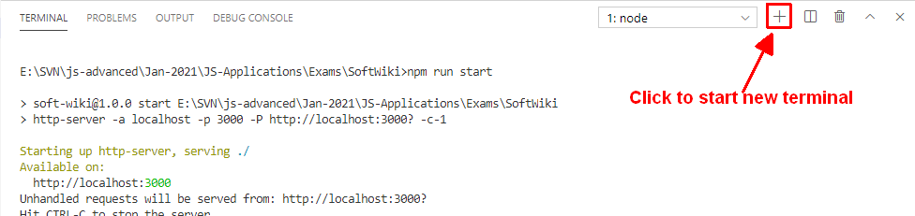

Test results will be displayed in the terminal, along with detailed information about encountered problems. You can perform this operation as many times as it is necessary by re-running the above command.

**Debugging Your Solution**

If a test fails, you can view detailed information about the requirements that were not met by your application. Open the file **e2e.test.js** in the folder **tests** and navigate to the desired section as described below.

**This first step will not be necessary if you are using the included web server.** Make sure the application host is set correctly:

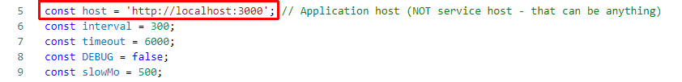

The value for **host** must be the address where your application is being served. Make sure that entering this address in a regular internet browser shows your application.

To make just a single test run, instead of the full suite (useful when debugging a single failing test), find the test and append **.only** after the **it** reference:



On slower machines, some of the tests may require more time to complete. You can instruct the tests to run more slowly by slightly increasing the values for **interval** and **timeout**:

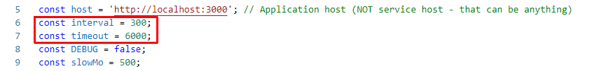

Note that **interval** values greater than 600 and **timeout** values greater than 10000 are not recommended.

If this doesn’t make the test pass, set the value of **DEBUG** to **true** and run the tests again – this will launch a browser instance and allow you to see what is being tested, what the test sees and where it fails (or hangs):

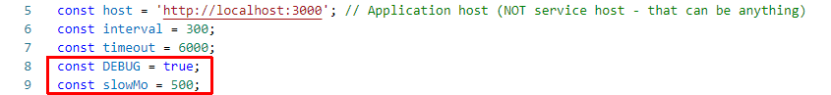

If the actions are happening too fast, you can increase the value of **slowMo**. If the browser hangs, you can just close it and abort any remaining tests by focusing the terminal window and pressing **[Ctrl+C]** followed by the letter "y" and **[Enter]**.

The final thing to look for is the exact row where the test fails:

